KEEP NEIGHBOURHOOD
LEGAL CLINICS!
PUBLIC MEETING: WED, OCTOBER 15, 6:00 p.m.
Scadding Court Community Centre, 707 Dundas St W (Dundas & Bathurst)
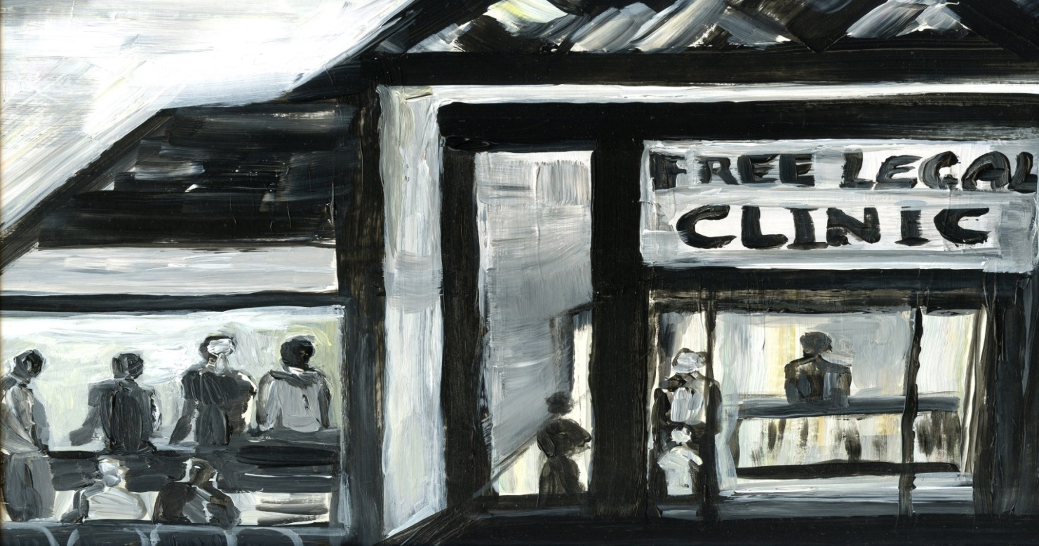
There are plans to close 14 community-based legal clinics in the City of Toronto and replace them with 3 mega service centres! Find out more information, and strategize to keep our legal clinics, and make them more accessible,
accountable and community based.
Immigrants, refugees, seniors, tenants, people with disabilities, unemployed people, low-wage workers, people from racialized communities and members of LGBTQ communities are encouraged to join us. Please let us know if you require accommodations to attend
(we will do our best to accommodate).
For more information, please contact: keepneighbourhoodlegalclinics@gmail.com

